**THINK-CHAMP PRIVATE LIMITED**

INTERNSHIP REPORT on

**PYTHON PROJECT : Shortening the URL**



SUBMITTED TO:

CEO OF THINK CHAMP PVT LTD

**GURU LOKESH SIR**

**SUBMITTED BY:**

**Neeli.varalakshmi**

**Renuka**

**B.Aparna**

INDEX

S.NO CONTENTS

1. Project-2------------------------------------------

1.1 Introduction ------------------------------------

1.2 Steps --------------------------------------------

1.3 Software requirements specification ----

1.4 Coding -------------------------------------------

1.5 Output ------------------------------------------

1.6 Conclusion --------------------------------------

**Project-2:**

* 1. **Introdu** **ction**

URL means Uniform  
Resource Locator and is a mention of/comment on (an address) to a resource on the Internet. A URL has two main  
to a resource on the Internet. A URL has two main  
components: Protocol identifier: For the URL  
http://example.com , the protocol identifier is http .  
Resource name: For the URL http://example.com ,  
the resource name is example.com .The most of  
the url's are consisting of long length. In this  
project we are shortening the length/reduce the length of url by using python.

* **. Steps**Steps to Create Shorten URL's  
  In command prompt  
   🡪 First Checking the version of python(python--version )  
  🡪Now installing the shorteners to shorten the url's.(pip install pyshorteners),  
  and next installing the pyperclip which is used for copy and paste purpose(pip install pyperclip)  
  In IDLE  
  ◆ Here importing the module called as pyshorteners.  
  ◆ Now creating a variable(url) to give user input.  
  ◆ Create a function by passing function name  
  and parameter as a (url).  
  ◆ In that function again creating a variable called  
  "s".And inserting pyshorteners.Shortener( ).  
  ◆ Now it will print as s.tinyurl.short(url).  
  ◆ Finally we get the tiny/short url with the help of function calling.

**1.3 Software requirements specification**

S0FTWARE REQUIREMENTS:

• Operating System: Windows 11

• Coding Language: PYTHON

• Software: PyCharm

HARDWARE REQUIREMENTS:

• System: PAVILION

• Hard Disk: 512GB

• Ram: 8 GB

**1.4 Coding**

In command prompt  
python -- version  
pip install pyshorteners  
pip install pyperclip

**CODE:**

import pyshorteners

url=input("enter the url")

def shorteners(url):

s=pyshorteners.Shortener()

print(s.tinyurl.short(url))

shorteners(url)

**OUTPUT:**

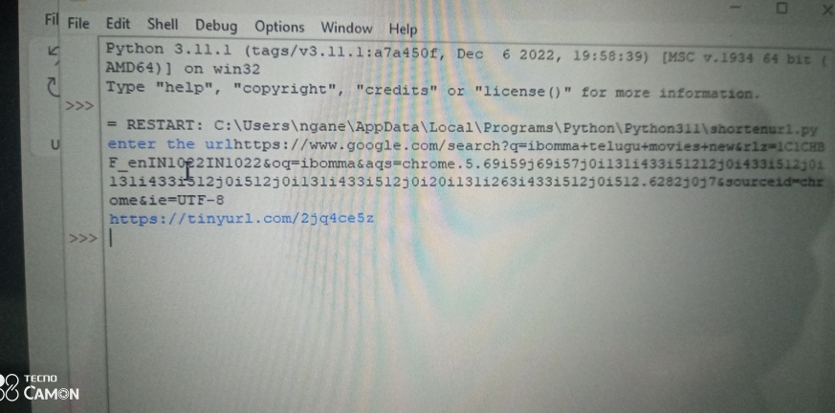

**1.6 Conclusion**

The shorten url is a simple program to  
shorten or minimise the url. By using this we can  
bring the tiny size url, and it occupies less space in memory.